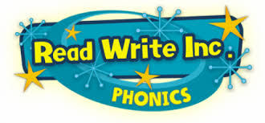
Read Write Inc
At Little Heaton CE Primary we use a synthetic phonics programme to teach reading called 'Read Write Inc' produced by Ruth Miskin. As children progress and can decode fluently they move onto the Literacy and Language scheme which develops children’s comprehension, vocabulary, writing, critical thinking and discussion skills and grammar – in a fun and meaningful way.
Read Write Inc Phonics is a method of teaching reading which is centred around learning the sounds of the letters (phonics), and then blending them together to read words. The children also learn to break down words into individual sounds in order to write them.
How it works
The children are assessed and grouped according to their ability.
They work in small groups with a teacher and a teaching assistant.
At the end of each half term the children will be assessed again to check they have made progress and will be grouped again. In addition to the Read Write Inc programme the children will also be working on writing skills and storytelling in their classes with their own class teacher.
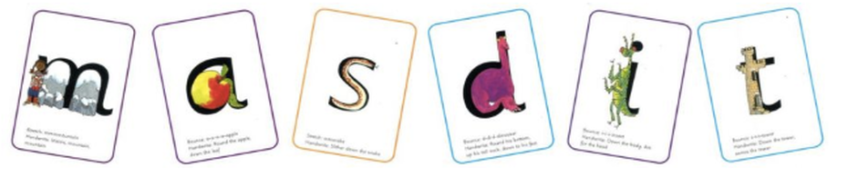
Reading
Using Read Write Inc the children learn to read effortlessly so that they can put all their energy into understanding what they read.
When using 'Read Write Inc' to read the children will:
Learn 44 sounds and the corresponding letter/letter groups using simple picture prompts
Learn to read words by blending the sounds together
Read lively stories featuring words they have learnt to sound out
Show that they understand the stories by answering 'Find It' and 'Prove it' discussion questions.
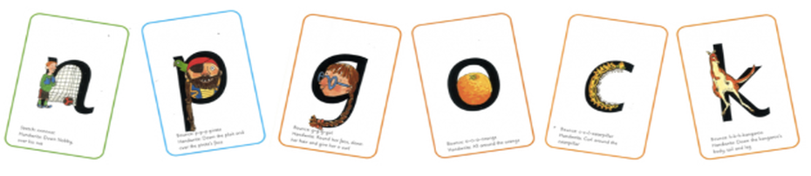

Writing
Read Write Inc allows the children to spell effortlessly so that they can put their energy into working out what they want to write.
When using 'Read Write Inc' to write the children will:
Learn to write the letters/letter groups which represent the 44 sounds (graphemes)
Learn to write words by sounding them out and then writing the corresponding graphemes
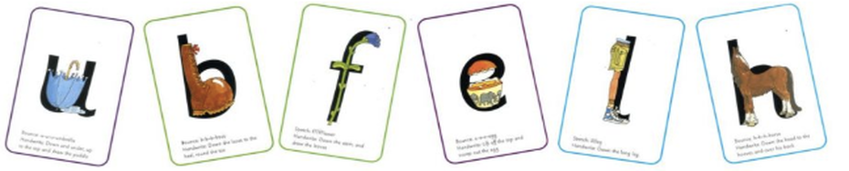
Talking
When using 'Read Write Inc' the children work in pairs to:
Answer questions to practise every activity
Take turns talking to each other
Give positive praise to each other.
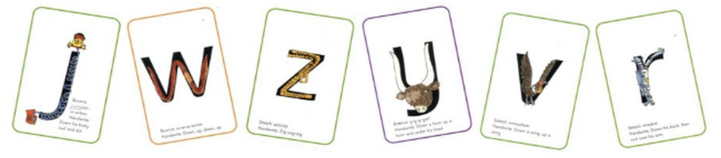
Blending
Children learn to read words by blending the letter-sounds that are in the Speed Sound sets
(shown further down the page).
Help your child learn to read words by sound-blending e.g. c-a-t = cat
Help children to say the pure sounds, as quickly as they can, and then to blend the sounds together to say the whole word.

Set 1 sounds
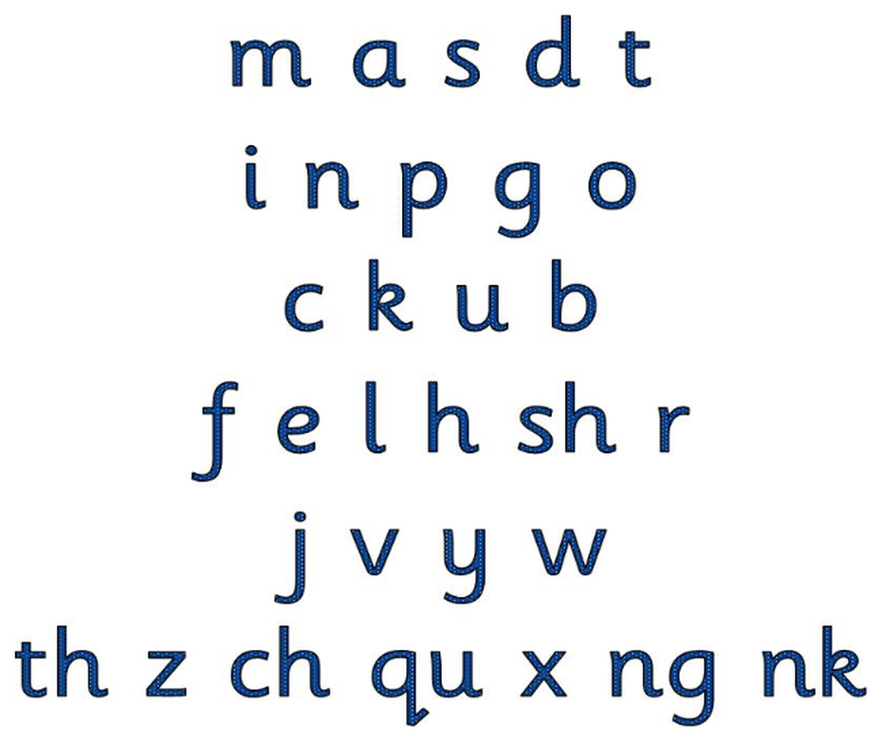

Set 2 sounds
Set 3 sounds
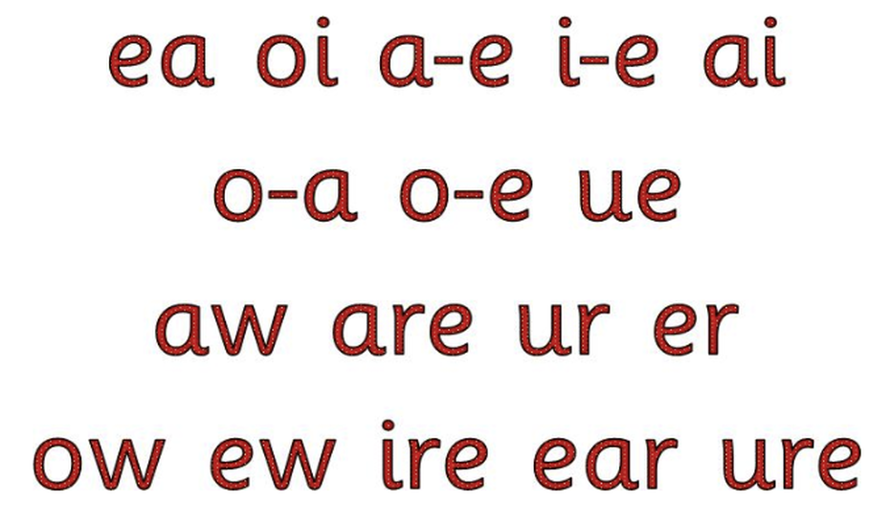
How will I know how to pronounce the phonic sounds?
Visit the Read Write Inc Parent's Page

