PE Funding

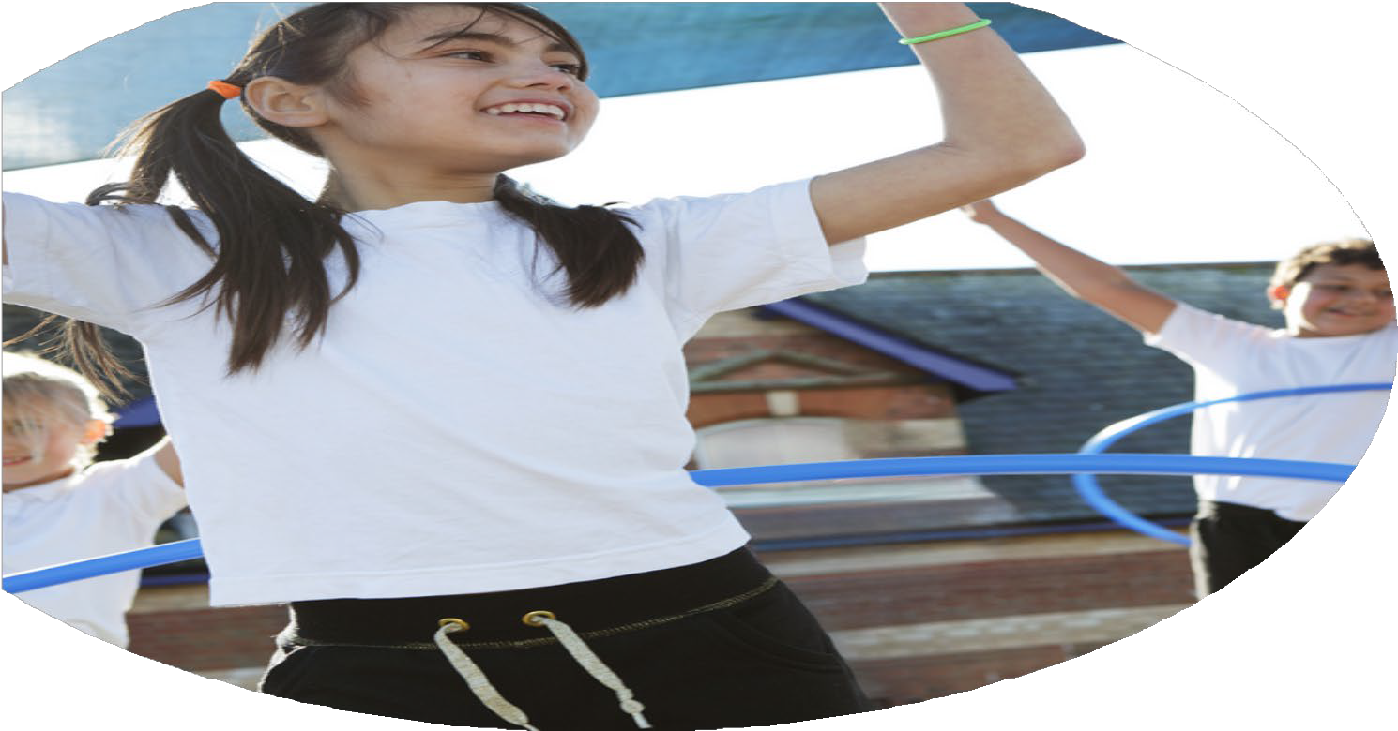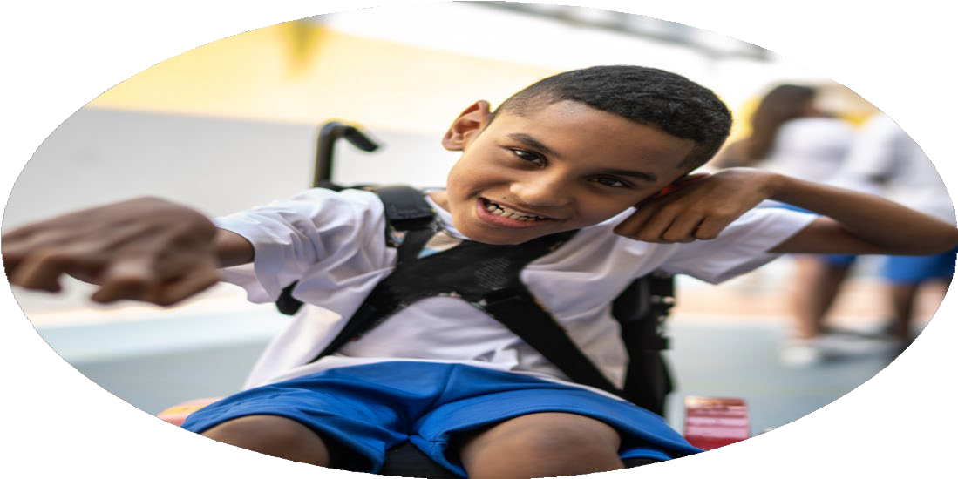

Evaluation Form

**Commissioned by**

**Created by**

Images courtesy of Youth Sport Trust

**PE Funding Evaluation Form**

Image 17 It is intended that this template should be used as preparation for the completion of the statutory digital reporting tool being introduced this academic year. You can upload data (including swimming) from this template onto this platform once it becomes accessible.

Image 18 Before you decide how you are going to use the funding for this academic year you should reflect and evaluate the impact of your use of the funding in 2023/24.

Image 19 All spending of the funding must conform with the terms outlined in the Conditions of Grant document. Image 20 The template is a working document that you can amend/update during the year.

Image 21 Based on your evaluation of last year’s funding you should decide what you intend to do this academic year, how you will do it, and what impact you expect it to have.

It is important that the funding is used effectively and based on your school’s needs.

Image 22 You must use the funding to make additional and sustainable improvements to the PE and sport in your school. Image 23 You must develop and add to the PESSPA activities that your school already offers.

*Summative digital reporting from June 2025 will continue to include swimming and water safety information therefore funding can be used to provide top-up lessons where necessary to ensure pupils meet national curriculum swimming requirements.*

**We recommend that you start by reflecting on the impact of current provision and reviewing your previous spend**

|  |  |  |  |
| --- | --- | --- | --- |
| What went well? | How do you know? | What didn’t go well? | How do you know? |
| Introduction of a whole school program.  Running  Field Games | Increase in positive input. Staff feedback. | Introduction of a new P.E plan to meet National Curriculum and replace the Cambridge Scheme. | It wasn’t bought/not found the right one that suits our needs. |

|  |  |
| --- | --- |
| What are your plans for 2024/25? | How are you going to action and achieve these plans? |
| Intent | Implementation |
| To consolidate and improve whole school provision.  To incorporate Year 5 non-swimmers and children who have not met NC in Year 4 to return for extra input.  Work closer with Middleton Parish School’s Sports Association (MPSSA). | The P.E is now Thursday KS1 Eyfs  Friday KS2. 2 slots have been allocated to all classes. Working with new Year 5/6 teacher regarding planning and equipment.  Identified children from last year and Children have started going with Year 4. Positive feedback from Year 4/5 teachers.  To create a wider opportunities for our children to take part in a wider scheme of sporting activities. |

|  |  |
| --- | --- |
| What impact/intended impact/sustainability are you  expecting? | How will you know? What **evidence** do you have or  expect to have? |
| Cambridge Program to meet NC outcomes. It ensures we meet our ‘Links Documents’ and builds on prior learning.  Bigger take up of active after school’s sports events in Running  .  Lunchtime supervised games on the M-U-G-A. Football dominates and caused a high level of conflict during unsupervised breaks.  School Swimming.  Other MPSSA events are planned in, to include a variety of sporting activities. | NC outcomes will continue to improve, or will begin to improve.  Children wii take part in the Middleton Parish School Sports Association (MPSSA) running events after school.  Children will have access to a wider range of sporting activities. Less unrest, arguments at lunchtime.  To increase children reaching NC 50 metres by EOKS2.  Children will participate in inter-school sports events and have wider opportunities in sports events. |

|  |  |
| --- | --- |
| What **impact/sustainability** have you seen? | What **evidence** do you have? |
| Having 2 slots on a single day has brought an excitement to ‘Sports days.’ Most children come in to school in sports uniform as parents find it easier to remember. And linked to PSHE it builds a sense of wellbeing and fun to the school day.  MPSSA Running events.  Supervised Lunchtime sport.  School Swimming  Other MPSSA events planned. | Teacher and parent feedback has been very positive. Children have reacted positively. A number of classes outside at the same time has added a level of excitement to the lessons.  Ann increase in number of children taking part in the cross-country events.  Wider range of sports accessed by a wider range of children. Less conflicts and arguments.  2 Children identified, should give 100% pass rate for 2025-26.  Sports-hall athletics, Badminton, Table Tennis for Autumn 2. Along with Boys & Girls Football League and Clayton Cup fixtures. Spring and summer to follow. |