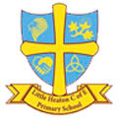

Talk 4 Writing is a literacy programme written by Pie Corbett. It enables the children to imitate story language orally, before reading it, analysing it and eventually writing their own versions. Talk 4 Writing is used throughout Little Heaton C of E from Early Years to Year 6. It is a powerful writing programme which provides our children with the skills and techniques needed to become amazing writers.

Talk 4 Writing follows 3 stages and each year group follows the same structure for each new genre.
Baseline Assessment and Planning.
Before each text is taught the children are asked to complete a baseline assessment or ‘have a go’ task. The teachers think up an interesting and rich starting point, it could be linked to the genre, setting, character or plot and the children can have a go at writing independently. This piece of work is then assessed by the teacher and used to plan for whole class, small group and even individuals for the next sequence of teaching.
The Imitation Phase
This sequence of teaching involves the ‘story telling’ part. Teaching hooks the children into the text, delving deeper into understanding the plot, the characters, the setting. Story maps are used with the children to enable them to immerse themselves into the text and actions are used to help children remember the main events of the story. Drama, hot seating, questioning are used to internalise the text and deepen their understanding.

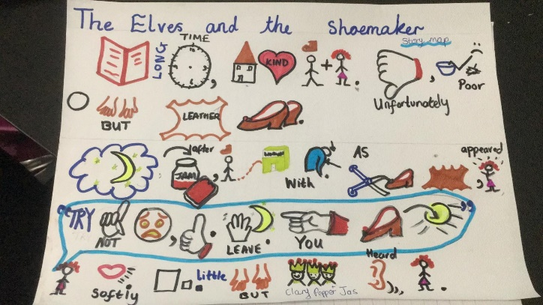

The Innovation Stage
Once the children are familiar with the story or text the teacher now guides the children through the sequence of creating their own version. The original story map is changed and adapted to create a new story. For our younger children this is guided heavily by the teacher and only certain things are changed, however the further up the school, the more alterations are changed through boxing up. The children are shown, through careful modelling by the teacher, how to create their own story paragraph by paragraph. There is a strong focus on grammar and sentence structure, incorporating the main them of the story/ text that is being taught. The children throughout this phase of learning focus upon rereading and editing their own writing and looking for ways to improve.
Toolkits are used to focus upon specific objectives that each year group needs to cover. They look more closely at the different genres of text types and the different aspects needed to write each story to a high standard. As the children move through the year groups these tool kits will be added to and developed.
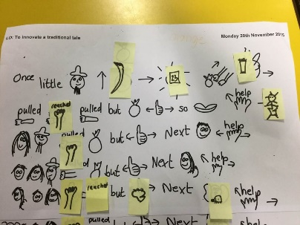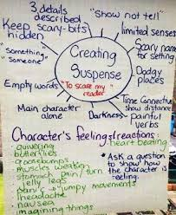
Invention Stage

The children have now been given lots of different tasks and situations to develop, structure and improve their own writing and they are now ready for their independent task. They will use their boxing up structure to assist them in planning their own writing. In KS1 this will be consist of slightly altering the original story but in KS2, children will be using the story structure, wider reading, writing tools and their own experiences to write at a higher level. The further up the school the children go, there will be a greater emphasis on moving away from the original text and they will become increasingly more skilled in independent writing.

