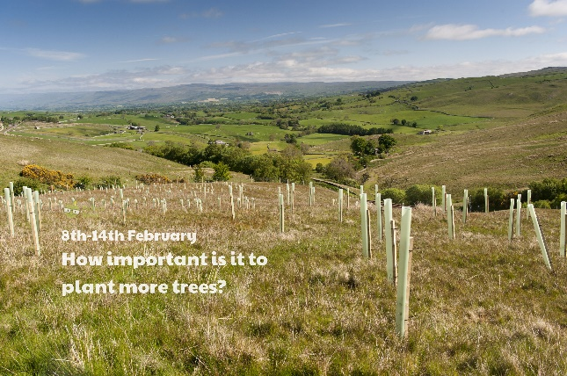 

Use home resource 1 to order and measure some leaves.

Different parts of the world have different trees. Where might you find a rainforest? Can you name a type of tree found on each continent?

Estimate the age of a local tree. Can you create a timeline of events that have happened in your tree’s lifetime?

Split a piece of paper into four, one section for each season. Draw what a deciduous tree would look like in each season. Will it have leaves? What colour will the leaves be?

Imagine you are in a forest or wood. Create a setting description. What can you see? Light glistening through the dense canopy. What can you hear? Branches creaking softly, leaves rustling like a never-ending whisper. What can you smell? The damp, earthy ground and the sweet pine cones. Make a collection of vocabulary and ideas before creating a paragraph to describe your forest setting. Try to use ambitious vocabulary and vary your punctuation and sentence openers.

Design your very own tree house! Which tree will you use? What will you make your treehouse from? Will it have windows, a roof? What will the inside of your treehouse look like? How will you get in and out of your treehouse? What will you use your treehouse for?

You can be as inventive and as creative as you like!

**Learning from home**

Use the ideas below, alongside this week’s resource, to support your home learning.