Subject Specific Vocabulary
experiment | Method used to prove or find out a fact
investigate | Carry out research to find out something
question | Scientific question helps to answer (figure out) the reason for an observation
prediction | Intelligent guess about what may happen in an experiment
results | Record of what happens in an experiment
microscope | A piece of equipment used to see tiny objects that the human eye would never be able to see
volume | An amount of water that can be measured in a container.
measure | Find the amount …  The amount of water collected is measured in millilitres
observe | To look at closely to find out result
equipment | Resources needed to carry out an experiment.
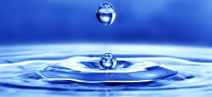
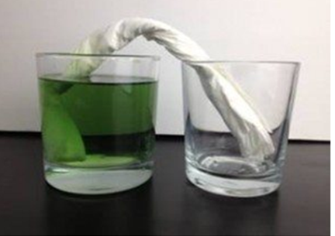
Experiments using water

Prior Knowledge – some materials absorb water e.g. paper towels.
-Some materials are waterproof e.g. plastic
- Grouping materials by their physical properties, grouping animals into carnivores, omnivores and herbivores.
Predictions can be right or wrong.
There are no wrong questions.

.

New Knowledge
People can investigate things in different ways – comparative test, observations over time, classifying, pattern seeking and research.
Results can be shown in different ways – tables, bar graphs, pictograms.
