1733 | Flying shuttle invented by John Kay: Improvement to weaving looms that enables weavers to weave faster. Creating a need for thread.
1742 | Mills begin to produce cotton in England.
1764 | The spinning jenny is invented – Spins more than one ball of yarn or thread at one time.  That same year Richard Arkwright invents the Water Spinning Frame. The first non-human powered textile machine.
1769 | James Watt improves the steam engine – Powers the first trains, steamboats and factories
1773 | The first all-cotton water powered mills begin mass-production of textiles.
1779 | Crompton invents the Spinning Mule creating mass-spinning of fine yarn for improved weaved fabric.
1785 | The Power Loom begins production. Increasing the speed and amount of woven material.
1790 | The first steam-powered textile mill is built by Arkwright.
1792 | Eli Whitney patents the cotton gin – Separates cotton seeds from cotton fibre. Creates modern fabric process.
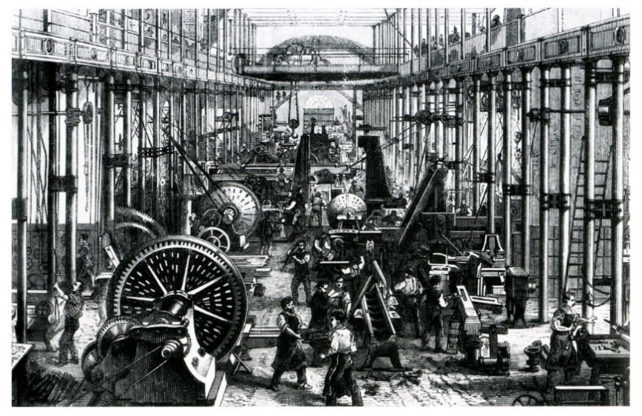
Industrial Revolution and the impact it had on the Cotton industry.
Timeline
Key Vocabulary
Immigration and migration. The clog, the shawl and the original Bob haircut.
Mills and The Factory System – workers and machinery together in one place
Industrial Revolution – machines take the place of people and animals
Mass production – Rapid (fast) production of identical objects
Interchangeable parts – identical pieces that could be assembled by unskilled workers
Urbanisation – The growth of cities due to movement of people from rural areas to cities.
Luddites – political group against the use of machines.
Peterloo – Middleton Riots – Civil unrest and violence. The rage against the machine.
Bridgewater Cananl: First non-river fed canal in the world built to transport coal to Manchester.
Legacy: What remains of the Industrial Revolution today.

Prior Knowledge: Historical understanding of our local area. Know who the Schwabbes family were and why Rhodes was built.
Know about the Lodges in Rhodes and the River Irk.
Know where Manchester – Middleton – Rhodes is on a map.
Know what the Warwick Mill is and know its location.
Understand the changes in society regarding crime & punishment through the Victorian Period.
New Knowledge: The Industrial Revolution is the transition of our society from farming to manufacture over a period of 150 years. It marked a major turning point in our history as every aspect of life changed. Inventions and engineering wonders brought great wealth, built upon an empire and changed our lives to this day. However, it is also a period of great poverty, child exploitation, social/political unrest and illness. The cotton industry in particular shaped our local area the most. We will look at the impact the Industrial revolution had on ordinary lives.

