Year 1 and Year 3 Camping Experience Day
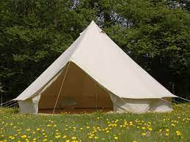
This Wednesday 12th July, the children in Year 1 and 3 will be joining us on the school field to take part in a fun packed day in the school’s camping village.
The children can come in their own clothes – but be prepared for the weather (suncream /hats/waterproof coat).
We will be outside all day long.
Trainers will also be needed.
See you then.
Mrs Crawford and Mrs Chambers.

